17th July, 2021

To Whom it May Concern

RE: CONFIRMATION OF EMPLOYMENT IN A PRIORITY OCCUPATION

The holder of this letter is employed by The Frank Whiddon Masonic Homes of New South Wales, trading as Whiddon. Whiddon is located at 81 Belmont Rd, Glenfield.

Whiddon is a not for profit organisation that provides care to older Australians across New South Wales and Queensland. As part of our care services Whiddon offers Residential Aged Care, Community Care, and Retirement Living options.

As such, we confirm that the work being performed by our employee is considered a priority occupation as outlined by the Department of Health and is eligible for the COVID-19 Vaccine in Phase 1B. Please note that staff employed at this site can access Covid Testing as part of their employment.

If you have any questions or concerns please contact the undersigned via email at s.flecther@whiddon.com.au or 9827-6666.

Yours sincerely
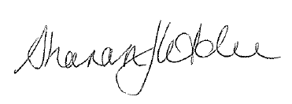

Sharon Fletcher
Operations Manager

